Calculus Based Physics 1: LAB
PHYS 2110 WA
Date: June 13, 2023
Isaac Abella

Experiment 4: Kirchhoff’s Rules (Multi-loop Circuits)

Groups:
Isaac Abella
Objective:
The objective of this experiment is to verify Kirchhoff’s rules applied to a two-loop circuit.

Equipment:
A computer with internet access, paper, pencil, and a scientific calculator.

Theory:
Ohm’s law is not efficient enough to solve for multi-loop circuits, which can contain unknown currents. In these circuits, the use of Kirchhoff’s rules are used to solve for the unknown currents. There are two rules that are used:

Kirchhoff’s Loop Rule (KLR) also called Kirchhoff’s Voltage Law (KVL)
Kirchhoff’s Junction Rule (KJR) also called Kirchhoff's Current Law (KCL)

A) KLR:

This rule states that: “The sum of voltage jumps and drops across the elements of any closed loop is zero”

This means that the voltages in a loop are either due to existing battery voltages V_{bat} , in which we just write down that voltage. Or because the current flowing in a resistor that we write the voltage across that resistor as the product RI.

The product RI is also a voltage. When writing KLR, we will just add the battery voltages and the RI voltages for all the resistors in the loop and set the sum equal to zero. However, there are also rules to determine which voltages are positive and negative.

1) Kirchhoff’s Rules for Batteries: When tracing a closed loop in either direction (whether it be in the clockwise or counter-clockwise directions), if you go from (-) to (+), then it is considered a voltage jump and so you would write down +V_{bat} for the battery. If you go from (+) to (-), then it is considered a voltage drop and so you write down -V_{bat} for the battery.

2) Kirchhoff’s Rules for Resistors: In each branch of a circuit, we need to assume a direction for the current at the beginning. If we assume the tracing direction opposes the current direction, known as I, we write down +RI, (Which is a voltage jump) across resistor R, and if the assumed tracing matches the assumed current, then we write -RI, (Which is a voltage drop) across that resistor.

A way to conceptualize the voltage jumps and drops is to imagine that the current of the circuit is just like the current of a river. If we were to swim against eh current of the river, we are trying to gain elevation in the river, which is like potential in a circuit, so this acts like a voltage jump. Swimming along the current flow would be going further down the river, which is like a voltage drop.

This can be verified using the figure below that shows a multi-loop circuit based on assumed direction of currents I_{1,} I₂, and I₃

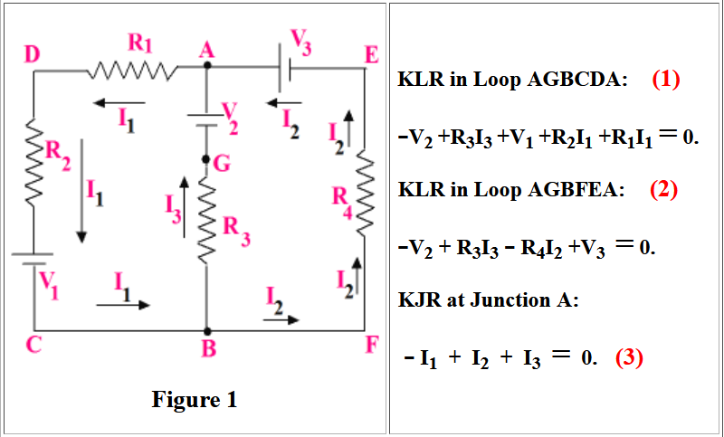

Choosing Current Directions:
We don’t actually know the true direction of the currents to begin with. We are just simply making assumptions for the current of each branch. If our initial assumption is correct, the answers at the end of our calculations should be positive, and if the answers at the end of the calculation turn out to be negative, then our initial assumption about the current direction was wrong.

B) KJR:
This rule states: “The sum of currents going towards a junction is equal to the sum of the currents leaving that junction.” This can also be a mathematical statement: “The algebraic sum of the currents to and from the junction equal zero.”

A junction is a point of connection in a circuit loop that consists of 3 or more wires at one point. In the equation above, in equation (3) in KJR is written for Junction A. I₁ leaves junction A and is given a (-) sign. Both I₂ and I₃ go towards junction A, so they are given (+) signs.

When observing the rest of the circuit from the left and right branches, we can see that the flow of the current and resistors is only going in one direction. The left branch only consists of a V_{ba}t, R₁, and R₂, so the flow of current would only be positive. When observing the middle branch of A and B, we see that the flow consists of multiple currents at their junctions, A and B. Therefore, we can see that the flow I₁, making it negative and I₂ and I₃ will be positive. For the right branch, the circuit consists of only a V_{bat}, R₄, and I₂, which makes the loop only positive.
Procedure:
After opening the PHET laboratory software for circuit construction, a loop following figure 2 provided by the lab manual was created. There are 3 cases that were followed, measured, calculated, and recorded in a data table below. After each case, the values were wiped and then adjusted per case.

When data was collected between resistors, the conventional flow setting inside of the lab software provided a means to see the flow of clockwise and counterclockwise flow in currents. This was used to determine if the flow between resistors in the Kirchhoff’s Loop and Kirchhoff’s Junction were positive and negative.

Observing the flow of R₁ and R₃ showed that the conventional flow from the batteries was flowing with the batteries, this would make them negative in the matrix calculations. For R₂, the flow from the battery to the resistor acted against one another, making it positive in matrix calculations.

Then, the values calculated through matrix solvers were compared to the ammeters that were attached to the multi-loop. The percent error was then calculated and plugged into the data table below.

Data:
Given and Measured:

Table 1:

Case | V₁  Volts | V₂  Volts | V₃  Volts | R₁  Ω | R₂  Ω | R₃  Ω | Currents | I₁  Amps | I₂  Amps | I₃  Amps
1 | 10.0 | 15.0 | 50.0 | 4.0 | 5.0 | 7.0 | Measured  Accepted  % Error | 2.83  2.831  0.035% | 1.27  1.265  .394% | 4.10  4.096  0.098
2 | 10.0 | 15.0 | 50.0 | 20.0 | 8.0 | 11.0 | Measured  Accepted  % Error | .80  .801  0.125% | 1.38  1.378  0.144% | 2.18  2.179  0.046%
3 | 85.0 | 20.0 | 40.0 | 40.0 | 8.0 | 6.0 | Measured  Accepted  % Error | 1.23  1.233  0.244% | 1.96  1.957  0.153% | 0.72  0.724  0.55%

Calculations:
When calculating the current flow of the left, middle, and right hand branches, the direction of the resistors and batteries are important to understanding whether there is a voltage jump or a voltage drop.

When calculating case 1, the direction of conventional flow between the R₁ and R₂ resistors flow in a counterclockwise movement, against their resistors, which makes them positive inside the matrix calculations (otherwise known as a voltage jump). However for case 2, when measuring the flow between R₂ and R₃ resistors, the conventional flow shows that the current is flowing with the resistors, causing a negative in the matrix calculation when accounting for resistor 3, and a positive for resistor 2 (otherwise known as a voltage drop).

Below is the written calculations for cases 1 – 3.

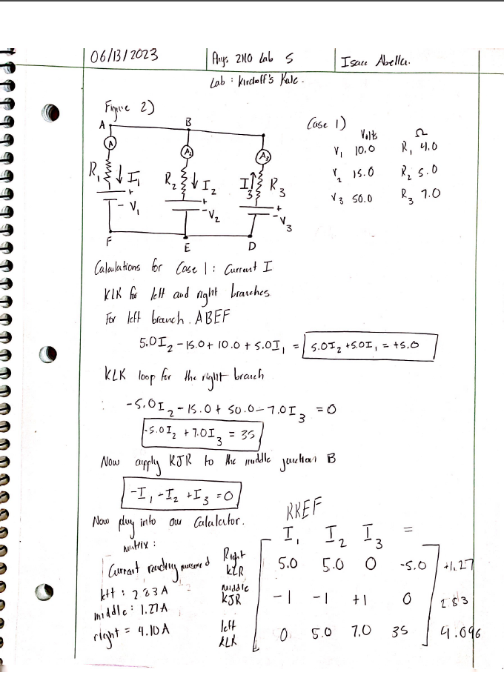
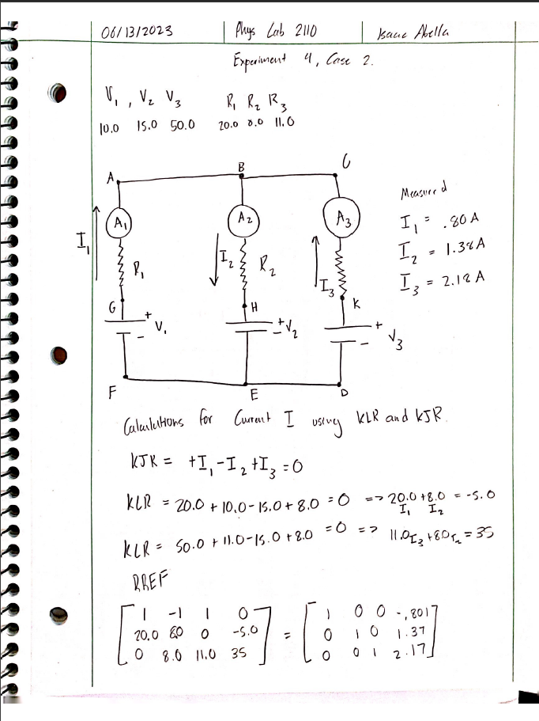
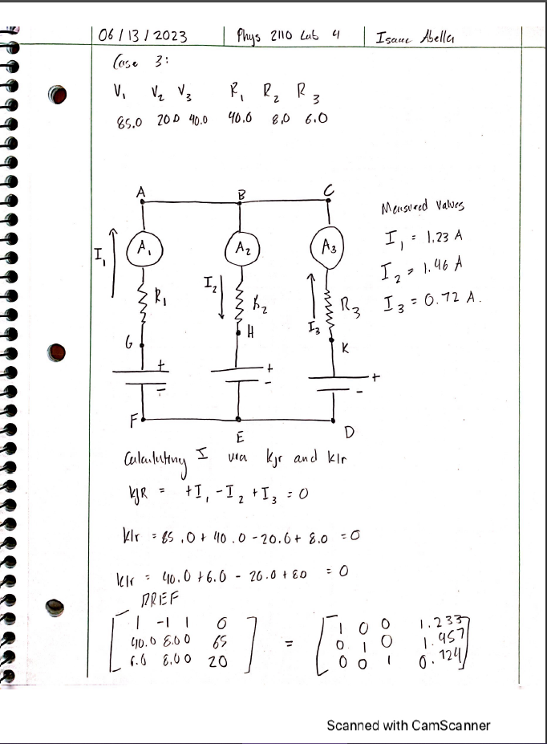
Comparison of Results:
Corresponding to every measured value, there is an accepted value. The calculated percent error was put into data table 1, and the results yielded low percent errors for each case tested.

Conclusion:
The objective of this lab was to verify Kirchhoff’s Rules applied to a two-loop circuit. All cases conducted yielded low percent errors in the acceptable range of < 1%, with the percent errors ranging form 0.03% – 0.50% as maximums.

The difference in measured an accepted values are based on the ti-84 plus ce’s rounding calculation in comparison to the PHET lab ammeter rounding. While the PHET software gives a rounded answer, the ti-84 matrix solver gives a raw answer that is then rounded to 3 significant figures.

Discussion:
When discussing errors that are possible in the lab, it most likely comes down to how Kirchhoff’s Loop Rule and Kirchhoff’s Junction rule was applied for all the loops. There is a left hand loop between the left and middle resistors, a loop in the middle between points B and E on the lab manual, and right hand loop between resistors 2 and 3.

Because of this, watching for the conventional flow between the batteries to their respective resistors is important. This is where the conductor of the lab makes the assumption of which direction to current flows in. When the flow is observed to flow along the resistor, then it can be identified as a voltage drop. But when the flow is observed to be flowing against the resistor, then it will be considered a voltage jump.

Keeping this in mind, not properly identifying positive or negative resistance values based on your assumption of the current can affect how the final answer comes our when using a matrix solver.
